***LINUX EXERCISES: PERMISSIONS***

1. List the permissions in your current directory, including hidden files.

**<ls -l>**



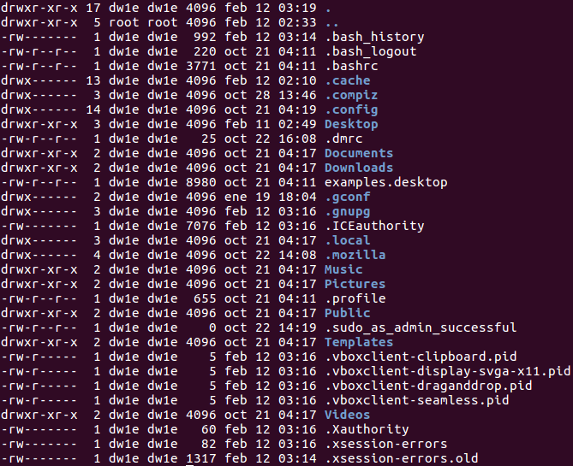

1. Create a file called perm1. Now, check the default permissions and user and group ownership

**<touch perm1>**

**<ls -l>**

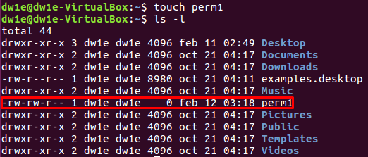



1. Change permissions of perm1 so that everyone can read and only the owner user can write. Specify the command in all possible ways

**<chmod a=r,u+w perm1>**

**<chmod go=r,u=rw perm1>**

**<chmod a=rw,go-w perm1>**

**<ls -l> →** to see the permissions







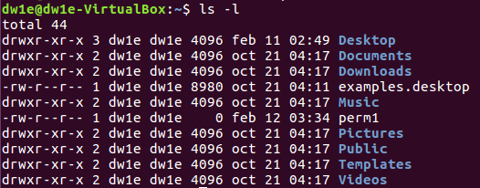

Also seen:

**<chmod 644 perm1>**



1. Create a file called script1.sh, including the content below. List the default permissions.

#!/bin/bash

clear

who

**<cat > script1.sh>**

**<ls -l>**

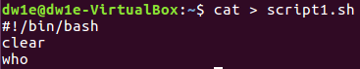



1. Remove the read permission from the owner and try to open the file.

**<chmod u-r script1.sh>**







It is impossible. Permission is denied.

1. Remove the write permission from the owner on the file script.sh. Add the line below. Is it possible? Why?

**<chmod u-w script.sh>**







(with nano)

1. Change the permissions on the file script1.sh so that the owner can read, write and execute, but you deny all the permissions from the group and others.

**<chmod a=-,u+rwx script1.sh>**





1. Add the line indicated in exercise 6, in case it was not possible. Try to run the file like a command.

**<cat >> script1.sh>**

** concatenate “new line”

**<bash script1.sh>**



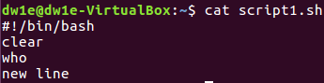





Also seen:

**<echo “new line” >> script1.sh>**

**\*\*** We can also run the script using **<./script1.sh>**

1. Remove the read permission from the owner on the file script1.sh. Try to run the file. Is it possible?





It is not possible. Permission is denied.



1. Create a directory called “systems”. Remove the write permission from it and try to copy script1.sh inside.

**<mkdir systems>**





**<chmod a-r systems>**





It is not possible, as we have no permission to read it.



1. If you were not able to copy the file, add the write permission again and copy the file inside.

**<chmod a+r systems>**

**<chmod a+r script1.sh>**

**<cp script1.sh systems>**





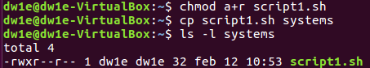

1. Remove the read permission from the user on the directory “systems” and try to list its contents.

**<chmod u-r systems>**





It is not possible. Permission is denied.

1. Change the permissions from “systems” so that the owner can read, write and execute, but the group and others can only read.

**<chmod a=r,u+wx systems>**





1. Remove the execute permission from “systems”. Can you execute systems/script1.sh? Is it possible to access the directory to execute the file?

**<chmod a-x systems>**

**<cd systems>**





It is impossible. Permission is denied.

1. Assign the execute permission to the directory again

**<chmod u+x systems>**





1. Create two files called “lucy” and “charles” into “systems”. Change permissions of “charles”, so that others can write and execute.

**<cd systems>**

**<touch lucy charles>**







1. Change permissions of “lucy” so that the owner can read and execute, the group can read and write and others can only write. Specify the command in all possible ways.

**<chmod u=rx,g=rw,o=w lucy>**

**<chmod 562 lucy>**







1. Log in as root. Change the ownership of “charles ”to “root”. Exit the root session. Now, try to change the permission so that others cannot read and execute. Is it possible? Why?

**<sudo su>**

**<chown root charles>**

**<exit>**

**<chmod o-rx charles>**

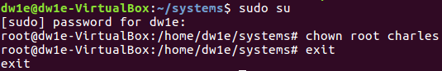



It is impossible. The operation is not permitted (the owner is root).

1. Change the permissions of “charles” so that everybody can do everything

**<sudo su>**

**<chmod a=rwx charles>**





1. Change the permissions of “lucy” so that the group can read and write, but the owner and others cannot do anything. Can you open the file?

**<chmod a=-,g+rw lucy>**







No, permission is denied.

(with solutions)

1. Create a group called “newgroup”. Set the group as the owner of the file “lucy” and “root” as the owner user.

**<sudo su>**

**<groupadd newgroup>**

**<chown root:newgroup lucy>**



1. Add your user to the secondary group “newgroup”. Try to open the file “lucy” now. Is it possible?

**<usermod -a -G newgroup dw1e>**





Now it is possible (but only being in root)

Now you belong to the group, but you are not the owner. Then, you are able to read and write

1. Change permissions of “lucy” so that everybody can read.

**<chmod a+r lucy>**





1. Do exercise 13 again, but this time granting permissions to the folder “systems” including files and subfolders

**<cd ..>**

**<chmod -R a=r,u+wr systems>**





1. Change the group owner of “systems” to “root” including files and subfolders.

**<chgrp -R root systems>**



**ALFREDO PUERTA GALLEGO DW1E**